Assignment
Subject: programing_fundamental_lab_4
Professor: Mr. Asad Majeed
Student Name: maheen Fatima
Class: bs computer science (1st semester)
Section: D
Roll number: 13
Date: oct 2026
GHAZI UNIVERSITY DERA GHAZI KHAN
Task1:
Write a program to print positive number entered by the user. If the
user enters negative number print number entered is positive otherwise
print number is negative.
#include<iostream>
using namespace std;
int main()
{
int a;
cout<<"enter a number: ";
cin>>a;
if(a>0)
{
cout<<"entered number is positive: "<<a;
}
else{
cout<<"entered number is negative: "<<a;
}
return 0;
}
Output:
enter a number: 1
entered number is positive: 1
>>>>>>>>>>>>>>>>>>>>>>
enter a number: -1
entered number is negative: -1
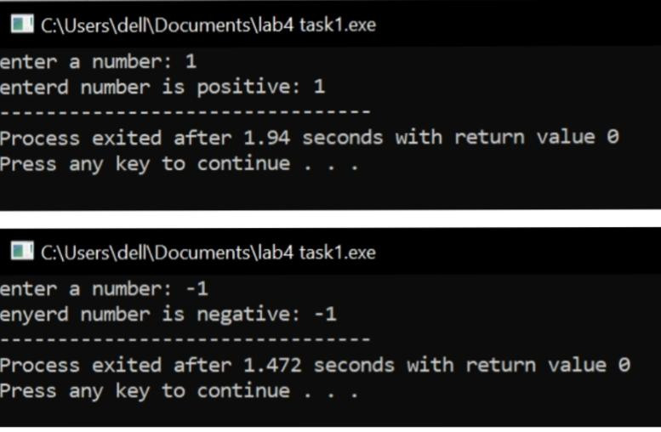
Task2:
Program to check whether an integer is positive, negative or zero.
#include<iostream>
using namespace std;
int main(){
int a;
cout<<"enter a number: ";
cin>>a;
if(a>0)
{
cout<<"the entered number is positive: "<<a;
}
else if(a<0)
{
cout<<"entered number is negative: "<<a;
}
else {
cout<<"entered number is ZERO: "<<a;
}
return 0;
}
Output:
enter a number: 3
the entered number is positive: 3
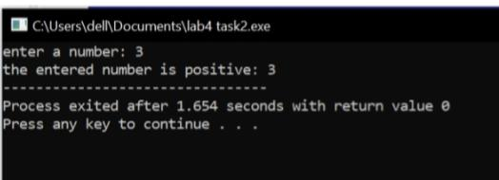
enter a number: -4
entered number is negative: -4
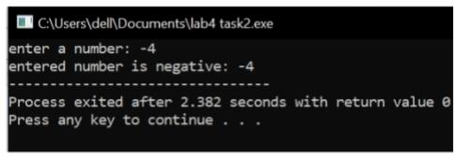
enter a number: 0
entered number is ZERO: 0
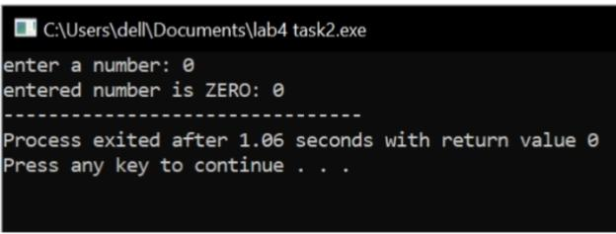
Task3:
Input: Mark Process:
If mark greater than and equal to 75, score will be A If mark less than 75
and greater than and equal to 60, score will be B If mark less than 60
and greater than and equal to 45, score will be C If mark less than 30,
score will be D output :
Print the grade of your score.
#include<iostream>
using namespace std;
int main(){
int marks;
cout<<"enter your marks: ";
cin>>marks;
if(marks>=75)
{
cout<<"Grade : A";
}
else{
if(marks>=60)
{
cout<<"Grade : B";
}else
{
if(marks>=45){
cout<<"Grade : C";
} else{
if(marks>30){
cout<<"Grade : D";
}
else{
cout<<"Better luck next time";
}
}
}
}
return 0;
}
Output:
enter your marks: 76
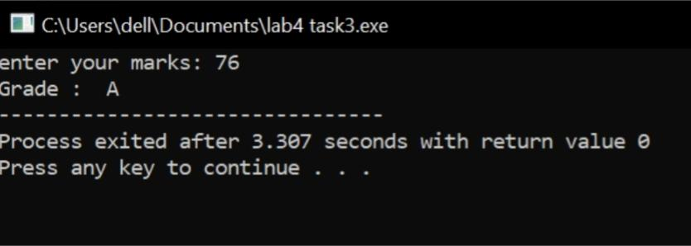
Grade : A

enter your marks: 66
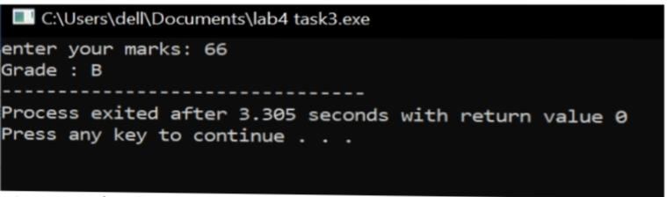
Grade : B
enter your marks: 46
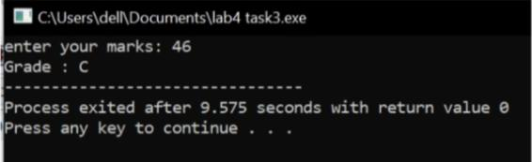
Grade : C

enter your marks: 36
Grade : D
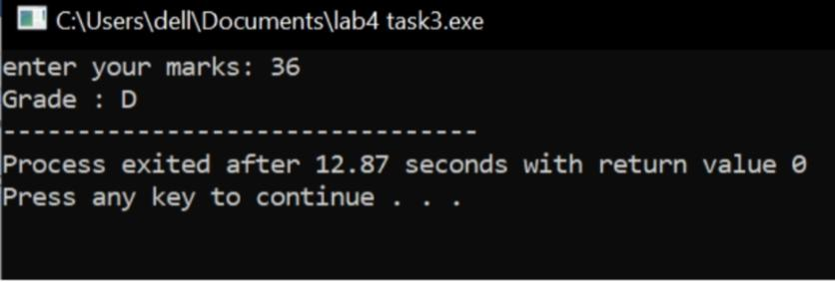
enter your marks: 28
Better luck next time
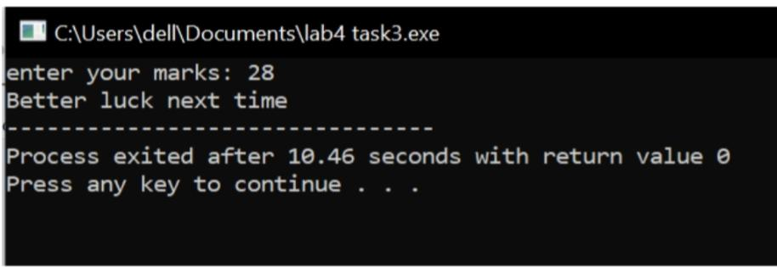
Task4:
Find Largest Number Using Nested if...else statement. Check whether
the number entered by the user is positive or not. If it is positive then
calculate how many digits the number have.
#include<iostream>
using namespace std;
int main(){
int a,b=0;
cout<<"enter a number: ";
cin>>a;
if(a>0)
{
while(a>0)
{
a/=10;
b++;
}
cout<<"the number is positive: "<<a<<endl;
cout<<"number of digits: "<<b<<endl;
}
else {
cout<<"entered number is not positive: "<<a;
}
return 0;
}
Output:
enter a number: 65
the number is positive.
number of digits: 2
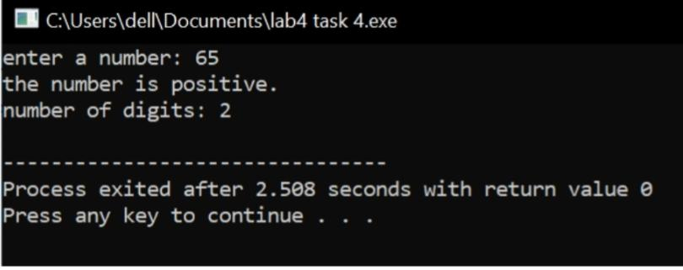
enter a number: 3
the number is positive.

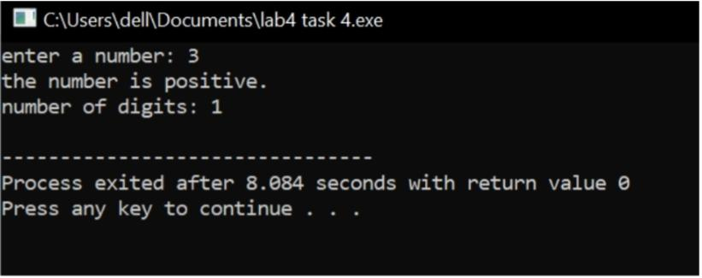
number of digits: 1
enter a number: -6
entered number is not positive: -6
